**Australian Islamic College 2019**

**ATAR Chemistry Units 3 and 4**

**Task 5 (Weighting: 3%)**

**Volumetric Analysis Test**

Test Time: 40 minutes

Please do not turn this page until instructed to do so.

|  |  |
| --- | --- |
| **First Name** | **Surname** |
|  |  |

|  |
| --- |
| **Teacher** |
|  |

|  |  |
| --- | --- |
| **Mark / 32** | **Percentage** |
|  |  |

Equipment allowed: Pens, pencils, erasers, whiteout, rulers and non-programmable calculators permitted by the Schools Curriculum and Standards Authority.

**Special conditions**:

2 marks will be deducted for failing to write your full name on this test paper.

**Teacher help**: Your teacher can only help you during your test in one situation.

If you believe there is a mistake in a question show your teacher and your teacher will tell you whether or not there is a mistake in the question and if appropriate, how to fix that mistake.

**Spelling of Science words** should be correct. Science words with more than one letter wrong (wrong letter and/or wrong place) will be marked wrong.

**Equations** must be written balanced and with correct state symbols or they will be marked wrong.

Questions must be answered in this booklet.

Total marks: 32

1. Here is a description of a titration.

A titration was conducted to determine the concentration of a solution of hydrochloric acid. 25.00 mL aliquots of hydrochloric acid were titrated against a standard solution of 0.150 mol L-1 sodium hydroxide.

The apparatus used in the titration is shown below.

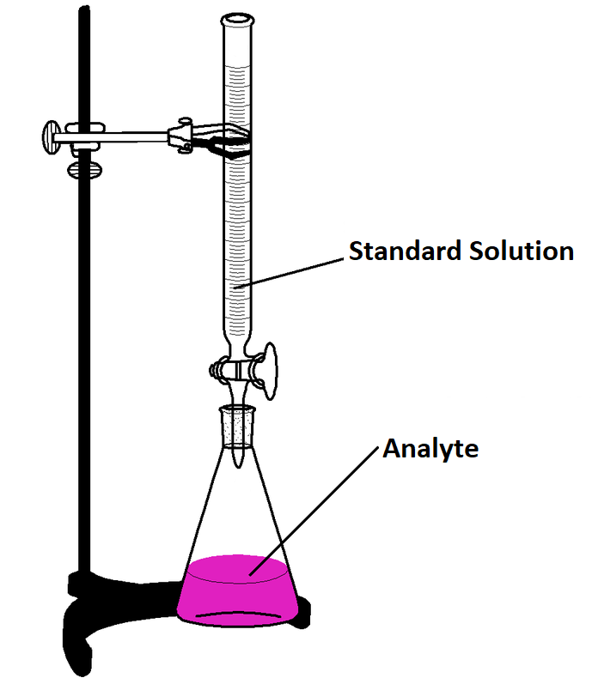

* 1. Referring to the diagram above, identify the following substances. Circle the correct answer from the choices given. [4 marks, 1 mark each]
     1. The substance placed in the burette for the titration.

HCl NaOH distilled water

* + 1. The substance placed in the conical flask for the titration.

HCl NaOH distilled water

* + 1. The liquid used for the final rinse of the burette.

HCl NaOH distilled water

* + 1. The liquid used for the final rinse of the conical flask.

HCl NaOH distilled water

* 1. Is the sodium hydroxide solution likely to be a primary standard solution or a secondary standard solution? Justify your answer. [2 marks]

* 1. The results of the titrations are given in the table below.

|  |  |  |  |  |  |
| --- | --- | --- | --- | --- | --- |
|  | Rough Estimate | Trial 1 | Trial 2 | Trial 3 | Trial 4 |
| Initial burette reading (mL) | 0.00 | 3.60 | 10.20 | 5.50 | 4.40 |
| Final burette reading (mL) | 37.20 | 38.60 | 45.30 | 40.60 | 28.60 |
| Titre (mL) |  |  |  |  |  |

What average value for the titre should be used for the calculations of the hydrochloric acid concentration? [1 mark]

* 1. Examination of the data in the results table above suggests a mistake was made during the titration and/or during the recording of results. Is this likely to be a random error or a systematic error. Justify your response.

[2 marks]

* 1. Determine the concentration of hydrochloric acid. [2 marks]

* 1. Explain how the calculated concentration of hydrochloric acid would be affected if the final rinse of the volumetric pipette was performed using distilled water. Circle the correct answer below.

[1 mark]

Final calculated concentration of HCl will be

Too high Too low Unaffected

* 1. Explain how and why the calculated concentration of hydrochloric acid would be affected if, every time the volume of liquid in the burette was measured, the burette was viewed from below the meniscus, rather than level with the meniscus.

[2 marks]

1. List four reasons why sodium hydrogen carbonate is a good choice of a solute to make a primary standard solution.

[2 marks; ½ each]

1. An experiment was set up to calculate the amount of citric acid present in lemon juice. Citric acid has a formula of C6H8O7 and is a weak triprotic acid. 8.00 g of the lemon juice was mixed with 50.00 mL of 0.500 mol L-1 NaOH(aq) and stirred thoroughly. The resulting solution was filtered and immediately titrated against 1.05 mol L-1 HCl(aq).

The average titre of HCl was 15.90 mL.

Calculate the % (by mass) of citric acid in the lemon juice.

[6 marks]

1. Phosphoric acid is a weak, triprotic acid. In a volumetric analysis experiment, a solution of approximately 0.2 mol L-1 phosphoric acid (H3PO4) is titrated with a standard solution of 0.200 mol L-1 sodium hydroxide in order to calculate the accurate concentration of the acid. 30.00 mL of the sodium hydroxide solution was pipetted into a conical flask, and the phosphoric acid added from the burette.
   1. Write an ionic equation, including state symbols, for the reaction occurring.

[1 mark; no half marks]

* 1. On the axis below, sketch a graph showing how the pH would be expected to change during the titration, until an excess of the acid was added.

[3 marks]

14

**pH**

7

1

**Volume of H3PO4 Added (mL)**

* 1. On the graph above, label the equivalence point for this reaction.

[1 mark]

|  |  |  |  |
| --- | --- | --- | --- |
| **Indicator** | **Approximate pH Range for Colour Change** | **Colour at Low pH** | **Colour at High pH** |
| **Methyl Orange** | **3.2 – 4.4** | **Red** | **Yellow** |
| **Bromothymol Blue** | **6.0 – 7.6** | **Yellow** | **Blue** |
| **Phenolphthalein** | **8.2 – 10.0** | **Colourless** | **Pink** |
| **Litmus** | **5.5 – 8.2** | **Red** | **Blue** |
| **Bromocresol Green** | **3.8 – 5.4** | **Yellow** | **Blue** |

* 1. Referring to the table above, give the name of an indicator that would be suitable for use in this titration.

[1 mark]

* 1. Describe the colour change that would occur that would indicate the endpoint of the titration.

[1 mark]

1. When preparing for a different titration 1.54 g of primary standard was dissolved in 250 mL of distilled water instead of 1.45 g, as intended. What type of error will this cause? Circle the correct answer from the three choices below. [1 mark]

Systematic / Random / No error

1. The titration curve below was produced by a group of students conducting an acid-base titration. 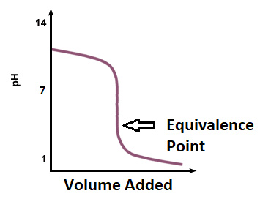
   1. Suggest any combination of acid and base that the students were using.

[1 mark for both answers correct, no half marks]

Example of acid being used:

Example of base being used:

* 1. What was in the burette during the students’ experiment, the acid or the base?

[1 mark]

**END OF TEST**